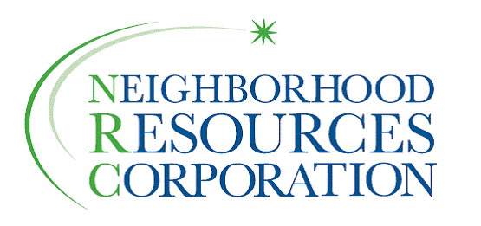

Neighborhood Resources Corporation

P.O. Box 1693. A South Bend, Indiana 46634

Board of Directors
2012-2013

Alkeyna Aldridge David Blouin
Community At-Large IU South Bend

Lynn Collier Donald D’Angelo
LaSalle Park Neighborhood Association Sunnymede Neighborhood Association

Noreen Deane-Moran Adam Gill, Secretary
Near West Side Neighborhood Organization 1st Source Bank

Jean Hanrahan Cecilia Lucero, President
Northeast Neighborhood Council Community At-Large

Pam Meyer Jerry Niezgodski
City of South Bend Lincoln Way West Gateway Association
Andre Northern Charles S. Reger
Community At-Large Chapin Park Neighborhood Association

Karla Riley Ron Silverman, Treasurer
Kennedy Park Neighborhood Association Community At-Large

Donald E. Sporleder Michael Whitt, Vice President
United Religious Community Community At-Large

